**Project Report.**

**Website design and development- Category 1.**

Team 4. Members:

1. Agada Solomon.
2. Yakubu Yakubu Abas.
3. Aliyu Ridwan.
4. Bisola Yasmin Oyeleke.
5. Shittu Amir Olayiwola.
6. Muhammad Maryam Lawal.

**Problem Definition.**

The need for an online shopping website is apparent when weighed against the problems and shortcomings of traditional shopping methods. The difficulty in finding the proper choices abound. These include problems finding the right size, colors, availability, issues with large crowds and queues.

The problem became even more prominent in the recent global lockdowns and shuttering of traditional stores. That’s where an online shopping website came in to fill the void and allow convenient shopping from the comfort of customers homes.

The solution is a website that can take in customer choices and provide candidate products for purchase using remote online secure payment methods along with home delivery systems that allow the full shopping steps to be performed from home.

**Design Specifications.**

The design specification is a HTML5 website, styled with CSS and running scripts using Javascript , for a dynamic website.

It was designed with modern website conventions of responsiveness and flexibility. With lots of multimedia for a user-friendly experience .

**Website features.**

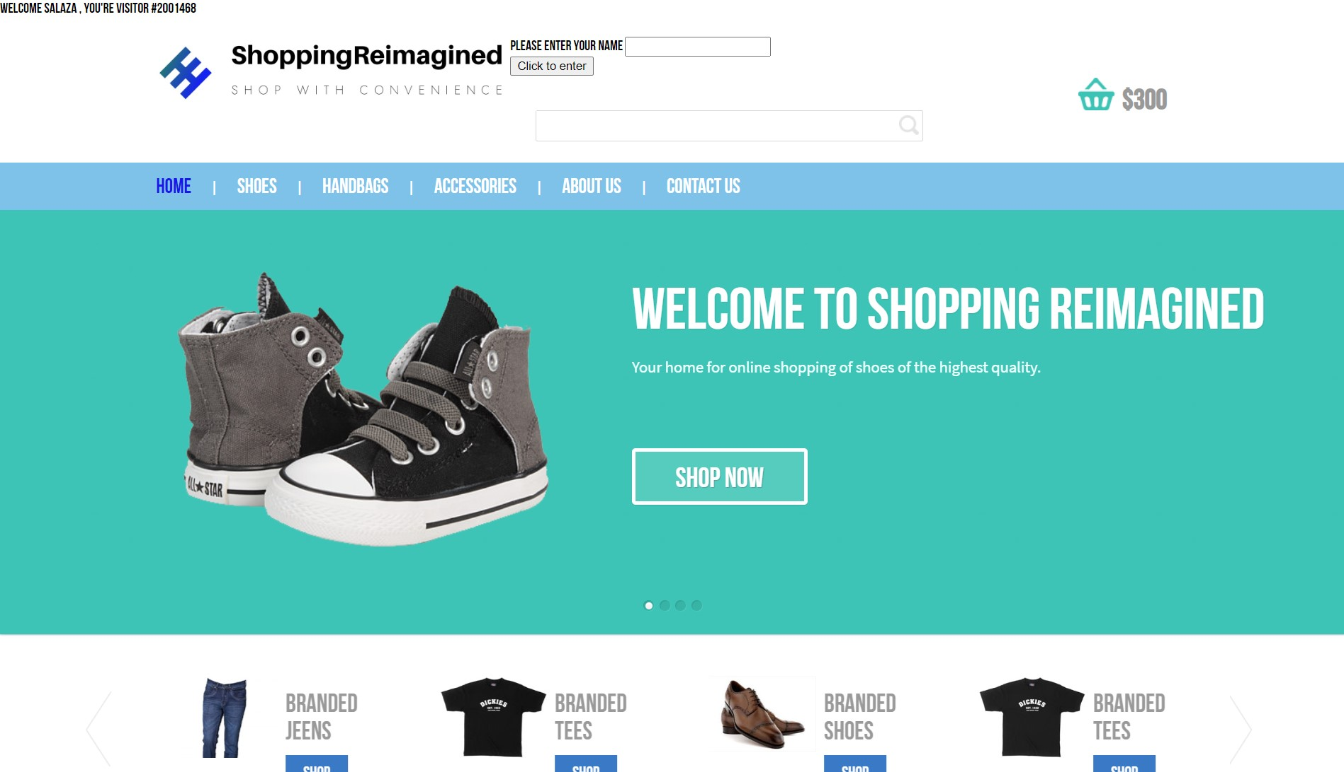

The website has many of the required features.

Personalized Logo.

Visitor count at the top left corner.

Place for input of user’s name for the display of a personal message in addition to a persistent custom message on every page.

Navigation buttons with color changes on hover.

A ticker at the bottom of the page which displays the current date and time.

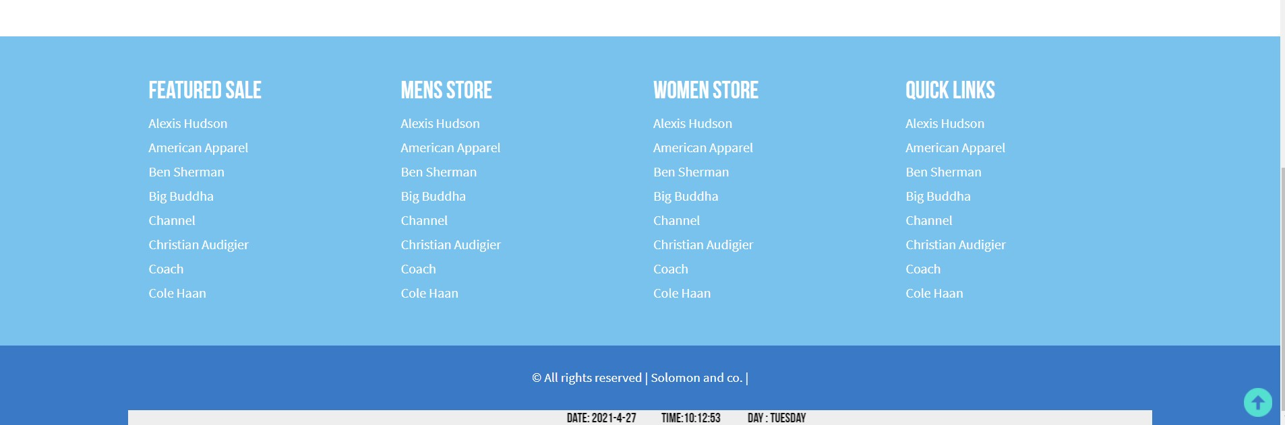

Picture. showing position of the ticker.

<div class="tcontainer">

                <div class="ticker-wrap">

                    <div class="ticker-move">

                        <div class="ticker-item"></div>

                        <div class="ticker-item">

                            <h2 id="displayDateTime"></h2>

                        </div>

                        <div class="ticker-item"></div>

                    </div>

                </div>

            </div>

            <script type="text/javascript">

                var today = new Date();

                var day = today.getDay();

                var daylist = ["Sunday", "Monday", "Tuesday", "Wednesday ", "Thursday", "Friday", "Saturday"];

                var date = today.getFullYear() + '-' + (today.getMonth() + 1) + '-' + today.getDate();

                var time = today.getHours() + ":" + today.getMinutes() + ":" + today.getSeconds();

                var dateTime = " Date: " + date + '&nbsp &nbsp &nbsp &nbsp &nbsp &nbsp Time:' + time;

                document.getElementById("displayDateTime").innerHTML = dateTime + ' &nbsp &nbsp &nbsp &nbsp &nbsp &nbsp Day : ' + daylist[day];

            </script>

Script and html element of the ticker element.

Data Flow Diagram.

The Website acts as an conduit between the end user or customer and the database which holds the product information such as shoes, handbags and accessories, as well as the personal information of the users as displayed in the diagram below.

